Today at 10:05 AM
I have been championing the cause of melatonin for years now.


Volume 13 | Issue 68

June 10, 2016

?
Can melatonin help treat
blood-based tumors?
?

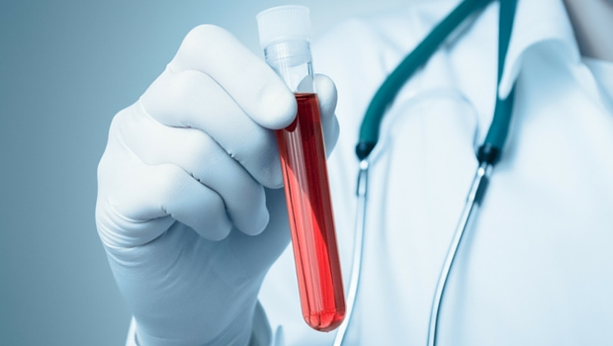
?

I have been championing the cause of melatonin for years now. An increasing number of studies indicate that melatonin protects normal cells from radiation and chemotherapy while at the same time reducing cancer-cell growth. It doesn’t get much better than that for an integrated cancer therapy. Which is why I now consider melatonin to be a standard for the treatment of all solid tumors. But what about the blood-based tumors, such as leukemia? A recent study looked at the answer to this question.
To do the study, the researchers added melatonin to cultures of human leukemia cells and found that it efficiently reduced the number of cells. Not only that, but the longer they exposed the cells to melatonin, the faster they died. And the higher the dose of melatonin, the faster they were killed. How did melatonin do it?
It did it by causing the release of cytochrome c from the mitochondria of the cancer cells. Cytochrome c is what cells use to stimulate apoptosis. I’ve talked about apoptosis before. It’s the mechanism that cells use to limit their growth. Cancer cells create all their problems because they won’t stop growing. They have learned how to avoid apoptosis.
The other thing melatonin did was to increase the production of the pro-apoptotic factor Bax. Many cancer cells lack the Bax factor, and can avoid apoptosis that way. The amazing thing is that melatonin restored apoptosis in these cancer cells. So, how important is this?

Think of this. The mere presence of cancer in the human body is virtually never a problem. The only problem with a cancer is when it grows without control. When that happens, at some point the cancer will invade surrounding tissues and organs or even spread to other parts of the body. Many of us have cancers that never cause a problem because our immune systems have found a way to control or limit their growth. So having a cancer that does not grow has the same effect as not having a cancer at all. And that’s why this study is so amazing. The melatonin actually stopped the growth of the leukemia cells and thus rendered the cancer harmless.
The data on the anti-cancer potential of melatonin is getting bigger as we speak. If you or a loved one is currently battling cancer, you need to be taking melatonin. And take it often and a lot. The study showed that the more you take and the more often you take it, the better it works.
The safety data on melatonin is astounding. So far no one has been able to find a toxic dose! Many of the leading researchers on melatonin in the world take more than 100 mg every day just to prevent cancer. I routinely start all my cancer patients on a minimum of 60 mg per day and use up to 200 mg per day. In addition, it can be taken throughout the day. So if you have cancer, talk to your doctor about adding melatonin to your treatment. It could save your life.
Yours for better health,


?

Frank Shallenberger, MD

==============
Below is the PubChem's page for melatonin indicating its molecular weight and the XL frequency calculation for it. The pills for Melatonin are inexpensive so perhaps we can use it only when we are temporarily run out of it or want to avoid additives.
Take care,
Melly

